Name:T.Harshitha

Date:06/01/2023

Python codes on 06/01/2023

Problem Statement 1:Merge Sorted Array

You are given two integer arrays nums1 and nums2, sorted in **non-decreasing order**, and two integers m and n, representing the number of elements in nums1 and nums2 respectively.

**Merge** nums1 and nums2 into a single array sorted in **non-decreasing order**.

The final sorted array should not be returned by the function, but instead be stored inside the array nums1. To accommodate this, nums1 has a length of m + n, where the first m elements denote the elements that should be merged, and the last n elements are set to 0 and should be ignored. nums2 has a length of n.

**Example 1:**

**Input:** nums1 = [1,2,3,0,0,0], m = 3, nums2 = [2,5,6], n = 3

**Output:** [1,2,2,3,5,6]

**Explanation:** The arrays we are merging are [1,2,3] and [2,5,6].

The result of the merge is [1,2,2,3,5,6] with the underlined elements coming from nums1.

**Example 2:**

**Input:** nums1 = [1], m = 1, nums2 = [], n = 0

**Output:** [1]

**Explanation:** The arrays we are merging are [1] and [].

The result of the merge is [1].

**Example 3:**

**Input:** nums1 = [0], m = 0, nums2 = [1], n = 1

**Output:** [1]

**Explanation:** The arrays we are merging are [] and [1].

The result of the merge is [1].

Source Code:

def merge(nums1,m,nums2,n)

        k = len(nums1) - 1

        while m-1 >= 0 and n-1 >= 0:

            if nums1[m-1] > nums2[n-1]:

                nums1[k] = nums1[m-1]

                m -= 1

            else:

                nums1[k] = nums2[n-1]

                n -= 1

            k -= 1

        while n-1 >= 0:

            nums1[k] = nums2[n-1]

            n -= 1

OUTPUT:

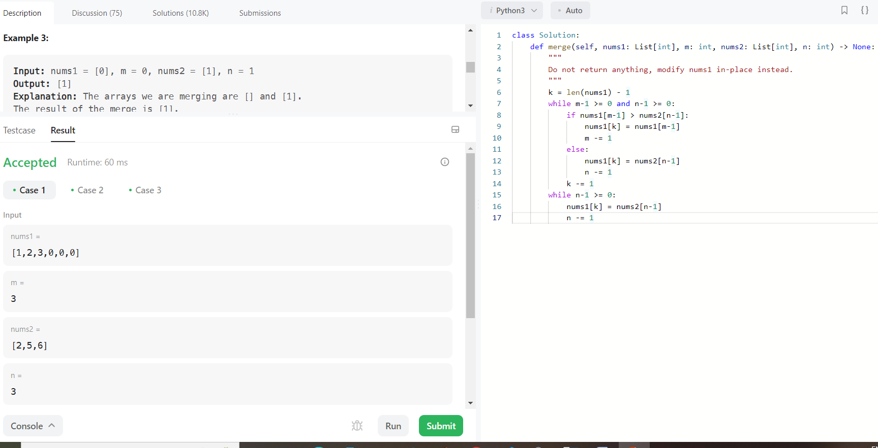

Problem Statement 2:  Largest Number

Given a list of non-negative integers nums, arrange them such that they form the largest number and return it.

Since the result may be very large, so you need to return a string instead of an integer.

**Example 1:**

**Input:** nums = [10,2]

**Output:** "210"

**Example 2:**

**Input:** nums = [3,30,34,5,9]

**Output:** "9534330"

Source Code:

def largestNumber(self, nums: List[int]) -> str:

        nums = map(str,nums)

        def comp(a,b):

            if a+b>b+a:

                # this means a need to go first

                return -1

            else:

                return 1

        nums = sorted(nums, key = cmp_to_key(comp))

        return str(int(''.join(nums)))

OUTPUT:

